**Quiz 2**

**Name:** Zack Roder

[Question 6, Section 3.3] A random sample of 42 firms was chosen from the S&P 500 firms listed in the Spring 2003 Special issue of Business Week. The dividend yield (DIVYIELD) and the 2002 earnings per share (EPS) were recorded for these 42 firms. These data are in a file named DIV3 (Canvas).

Using dividend yield as the dependent variable and EPS as the independent variable, a regression was run. Use the results to answer the questions.

1. What is the sample regression equation relating DIVYIELD to EPS? Write the equation in the standard form for writing a regression equation. (4 points)

**R Output:**

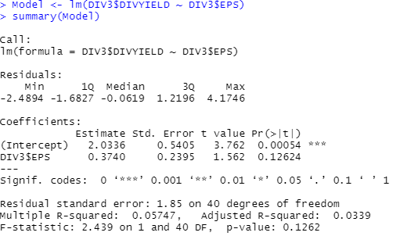

**Equation in standard form:**



2. Is there a linear relationship between DIVYIELD and EPS? Use $α=0.05$. Use the following five-step procedure that we have been using in class.

Step 1: State the null and Alternative hypothesis using correct notation. (4 points)

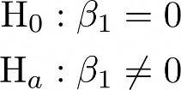

Step 2: Calculate the test statistic. (4 points)

**From the R output, we know that**



**To calculate the t-statistic by hand:**

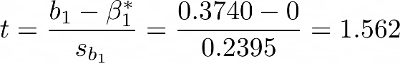

**Which corresponds with our R output!**

Step 3: Calculate the p-value. Clearly draw a diagram and show complete work. (4 points)

**To compute the p-value, we can use the R function pt() with df = n-2:**



P-value = ________________

Step 4: Make a decision (2 points)

(a) Reject $H_{0}$

(b) Do not reject $H_{0}$

Step 5: Write the conclusion is context of the problem (4 points)

3. Construct a a 95% confidence interval for $β_{1}$ (slope). Record your answer below using the 4-step procedure that we have been using in class.

Step 1: Write the equation (2 points)

Step 2: Identify the following values (use R to compute these values)

$\overline{x}=______________$ (2 points)

$s=______________$ (2 points)

$n=______________$ (2 points)

${ t}_{\frac{α}{2},n-1}=______________$ (2 points)

Step 3: Substitute to find the upper bound and the lower bound of the confidence interval. Show work

Lower bound: $______________$ (2 points)

Upper bound: $______________$ (2 points)

Step 4: Interpret the confidence interval in context of the problem (4 points):